ORDER ONLINE NOW ON MEMBERHUB
Open camera and hold over image below


Order your 2019-2020 yearbook today $25

Join the PTA and help support our community

Parent $15.00
Additional Parent/Student $5.00
Teacher/Staff $5.00

Picture Day
11/2 for Group A, 11/4 for Remote Students and 11/5 for Group B
All orders must be placed online
www.dantechester.com click order photos (keyword: DiChiaro2020)
All photos will be taken outside under a tent

Purchase your Take Home Carnival Goodie Bag $20
Each bag contains wooden paintable mask, ceramic paintable pumpkin votive, paints, brush, pencils, bouncy ball, thumbprint kit, bubbles & school mask

DiChiaro School Masks available (image on Memberhub) $8
Adult size (suggested 6th grade and up) w/ school name
Kids size (suggested pre-K to 6th) w/ dragon logo

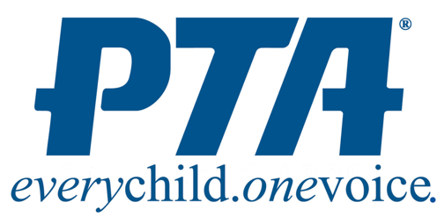
Questions
Call/text (914) 760 8863
DiChiaroPTA@gmail.com

